Bildlegenden co-operate EN
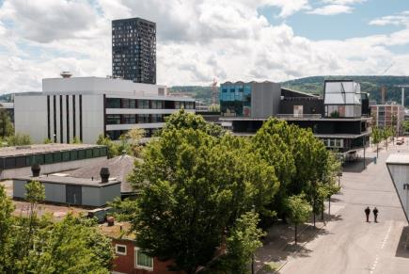 | The new Empa-Eawag research campus co-operate opened its doors in June 2024. (Image: Empa)
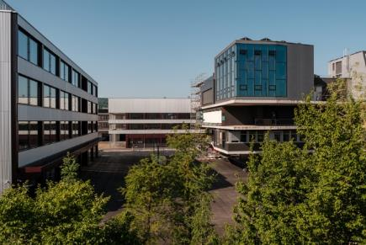 | The new facades – the laboratory building on the left and the multifunctional building behind – reflect the dynamics of the existing NEST building (on the right). (Image: Empa)
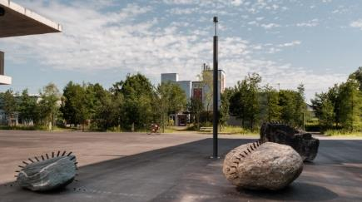 | The art installation "Not to get lost" by Swiss artist Julian Charrière on the campus square between NEST and the new laboratory building. (Image: Empa)
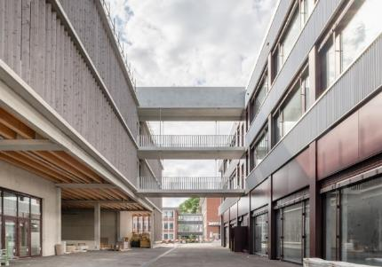 | The multifunctional building (right) contains the Flair bistro and offices. It is connected to the parking garage (left). (Image: SAM Architekten / Fabio Compagno)
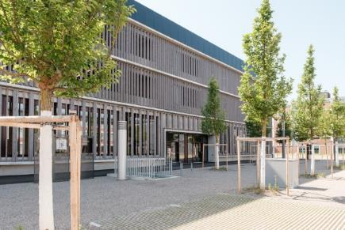 | The parking garage replaces open parking spaces that were scattered across the entire campus. (Image: Empa)
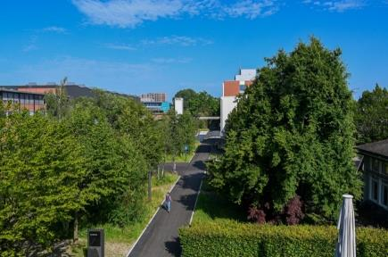 | Now practically car-free, the campus was given a "green belt" connecting the two research institutes Empa and Eawag. (Image: Empa)
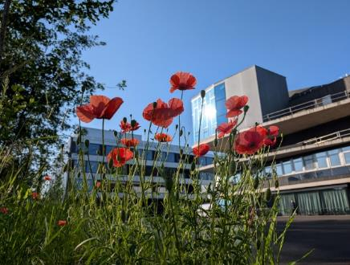 | Green spaces, trees and flowers make the campus more inviting and creates spaces for employees and guests to linger. (Image: Empa)
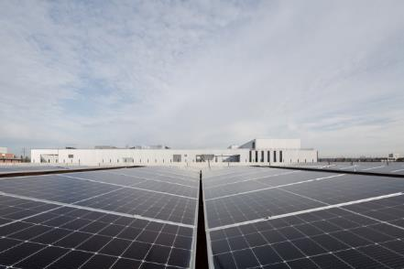 | In addition to the photovoltaic system on the roof, the parking garage also houses a new type of geothermal energy storage system. (Image: SAM Architekten / Fabio Compagno)
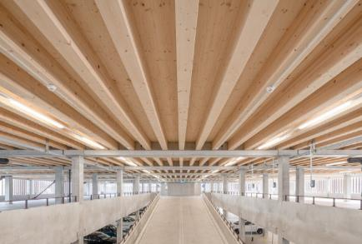 | The timber ceiling of the parking garage. (Image: SAM Architekten / Fabio Compagno)
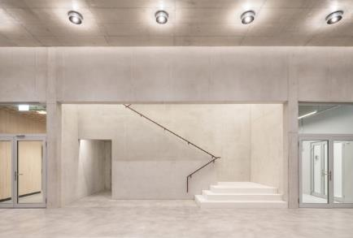 | The new laboratory building combines social, office, and lab spaces under one roof. (Image: SAM Architekten / Fabio Compagno)
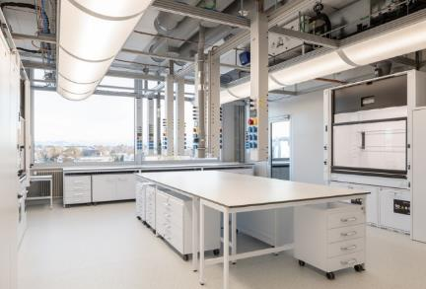 | The 30 or so modern laboratories offer plenty of space for research. (Image: SAM Architekten / Fabio Compagno)
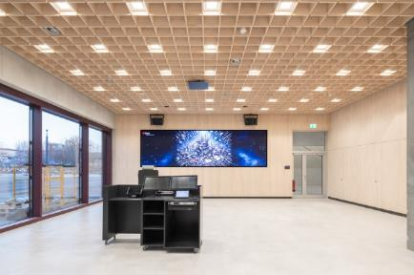 | The ground floor of the new laboratory building also offers room for events thanks to its multifunctional spaces. (Image: SAM Architekten / Fabio Compagno)
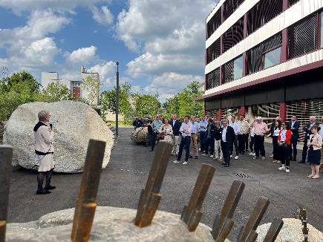 | The artwork "Not to get Lost" by internationally renowned artist Julian Charrière stands between the new laboratory building and NEST. At first glance, it is reminiscent of a giant's garden, playfully thrown down as an archaic antithesis to the urban architecture. Friederike Schmid, representing the artist, presented the artwork at the opening ceremony: "With this work, Empa and Eawag want to send a tongue-in-cheek impulse to the researchers – to take the path of science, which can sometimes lead over ‘rocky terrain’, with a little lightness and to embrace the playful flow of this installation". Image: Empa
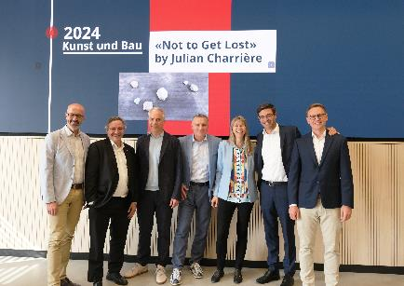 | Milestone reached: The co-operate research campus is open! From left to right: The Mayor of Dübendorf André Ingold, ETH Board President Michael Hengartner, Eawag Director Martin Ackermann, Empa Head of Department Urs Leemann, Empa Director Tanja Zimmermann, Implenia Head Division Buildings/Country President Jens Vollmar, Head of Empa Real Estate Kevin Olas. Image: Empa

