Ring structures that form by themselves
“We produce pretty, regular micropatterns – without so much as a pen, brush or printer in sight,” says Empa researcher Rita Toth. Teaming up with colleagues from the University of Basel and the University of Technology and Economics in Budapest, she studied chemical processes that form small, microscopic, concentric ring structures all by themselves. They can be used to produce Fresnel lenses, for instance, which used to focus the light in lighthouses and are very useful today as micro-components in fiber optical data transfer. The self-forming micro-rings might also be used to coat catalyst surfaces evenly and effectively.
The chemical basis for the self-forming ring structures are so-called Liesegang rings, named after the German chemist and photographic paper manufacturer Raphael Liesegang who first described them in 1896. His famous peer Wilhelm Ostwald then began to study the rings. Using state-of-the-art analysis methods, the Empa research team has now examined the formation process of Liesegang rings, which had not been understood entirely, in detail in their laboratory and on the synchrotron accelerator at the Paul Scherrer Institute – and made an unexpected discovery: Toth and her colleagues observed that the size of the rings could be adjusted practically at will by altering the chemistry. Distances between the rings of between a thousandth and a hundredth of a millimeter are possible. The striking thing here is that the rings form independently of each other. For the first time, the scientists were able to explain the principles according to which Liesegang rings form. The formation takes place according to the so-called Cahn-Hilliard equation, which describes an advancing front of a chemical reaction. Behind the front, a homogeneous precipitation forms, which settles periodically – and forms the visible rings. As a result, the phenomenon could now come within touching distance of commercial usage for inexpensive optical structures and coatings.
Concentric Liesegang rings, as produced at Empa.
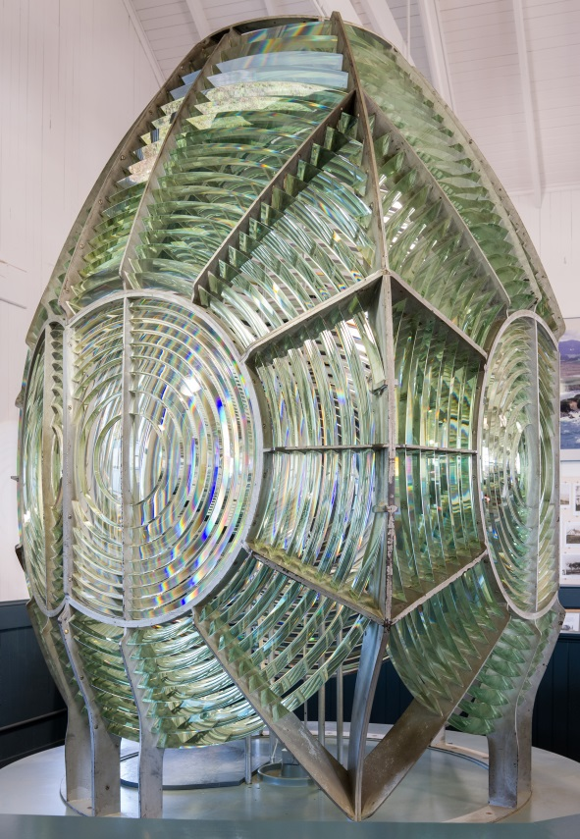
Fresnel lens at the Point Arena Lighthouse Museum, Mendocino County, California. Picture: Frank Schulenburg / Wikimedia

